Image Classification with Convolutional Neural Networks (CNN)
Shri G.S. Institute of Technology and Science, Indore, India

Submitted By:
Vedant Chitlangia | 0801IT231146 | vedantchitlangia2004@gmail.com
Vaibhav Tomar | 0801IT231141 | vaibhev.s.tomar@gmail.com
Group No. GB-6 | Batch B1 | Department of Information Technology | B.Tech 3rd Year
Mentors:
Dr. KK Sharma | Dr. Upendra Singh
Dr. Lalit Purohit | Mr. Akshay Gupta

Abstract
Image categorization is a core issue in computer vision, wherein algorithms are trained to assign images to specified categories. This study details the implementation and comparative analysis of two notable Convolutional Neural Network (CNN) designs, LeNet and VGGNet, utilizing the ciFAIR-10 dataset. ciFAIR-10 is a deduplicated version of CIFAR-10, consisting of 60,000 color photos (50,000 for training and 10,000 for testing) evenly categorized into 10 item classes: airplane, automobile, bird, cat, deer, dog, frog, horse, ship, and truck. Data preprocessing encompasses float32 normalization and one-hot encoding of labels. LeNet, an early compact CNN with around 62,000 parameters, scored a test accuracy of 61%, but the deeper VGGNet design, with approximately 7.8 million parameters, attained an accuracy of 77%, representing a substantial gain of 32 percentage points. The findings indicate that network depth and dropout regularization are essential for enhancing classification performance, though they require increased processing resources. Both models were trained utilizing the Adam optimizer with categorical cross-entropy loss over 30 epochs and a batch size of 64.
Keywords:
Convolutional Neural Network, Image Classification, LeNet, VGGNet, ciFAIR-10, Deep Learning, Feature Extraction

1. Introduction

Image classification is a fundamental job in computer vision that allows machines to provide a category label to a certain image from a predetermined set of classes. The rapid proliferation of visual data on the internet, social media, and scientific fields has rendered automated picture identification indispensable for several practical applications, including medical diagnosis, autonomous cars, security surveillance, and remote sensing.
The primary issue in picture classification is reconciling the semantic disparity between raw pixel values and abstract human-understandable notions. Conventional machine learning methods depended significantly on manually generated feature engineering techniques like SIFT, HOG, and LBP, necessitating domain expertise and exhibiting poor generalization across varied datasets. The emergence of deep learning, especially Convolutional Neural Networks (CNNs), revolutionized this field by facilitating end-to-end feature learning directly from unprocessed pixel data.
This study examines and contrasts two historically important CNN architectures, LeNet and VGGNet, for the purpose of multi-class picture categorization. LeNet, introduced by Yann LeCun in 1998, was among the first successful CNN architectures and established the groundwork for contemporary deep learning. VGGNet, presented by the Visual Geometry Group at Oxford University in 2014, illustrated that the depth of a network is a pivotal element in attaining superior classification accuracy.
This work's primary contribution is a thorough comparison analysis of the two architectures using the ciFAIR-10 benchmark, assessing accuracy, training dynamics, and per-class performance. This paper is structured as follows: Section 2 offers a literature review of CNN-based image classification techniques; Section 3 delineates the methodology, encompassing architectural specifics, flowcharts, and algorithmic design; Section 4 addresses implementation particulars, dataset characterization, and evaluation metrics; Section 5 presents results and discussion; and Section 6 concludes the paper with recommendations for future research..

2. Literature Review
Convolutional Neural Networks have shown swift advancement since their creation. LeCun et al. (1989) pioneered gradient-based learning for document identification by introducing the LeNet architecture, which utilized convolutional layers to achieve high accuracy in recognizing handwritten numbers. This seminal work introduced the fundamental principles of local connection, weight sharing, and spatial hierarchies that continue to be integral to contemporary CNNs.
Krizhevsky, Sutskever, and Hinton (2012) presented AlexNet, which achieved a substantial victory in the ImageNet Large Scale Visual Recognition Challenge (ILSVRC). AlexNet showcased the efficacy of deep convolutional neural networks trained on GPUs, popularizing ReLU activations and dropout regularization, hence catalyzing the extensive adoption of deep learning in visual recognition tasks.
Simonyan and Zisserman (2014) introduced VGGNet, an extensively deep CNN architecture with diminutive 3x3 convolutional filters. VGGNet demonstrated that the depth of a network is essential for attaining state-of-the-art performance. The architecture's minimalism and consistent design established it as a prevalent foundation for numerous future investigations, and pre-trained VGGNet models have been extensively utilized for transfer learning.
He et al. (2016) tackled the vanishing gradient issue in extremely deep networks by proposing Residual Networks (ResNets), which employ skip connections to facilitate direct gradient flow throughout the network. ResNets facilitated the training of networks of hundreds of layers and attained exceptional performance across several vision benchmarks.
Howard et al. (2017) presented MobileNets, lightweight convolutional neural network designs that employ depthwise separable convolutions to significantly decrease computational demands and model size while preserving competitive accuracy. This research established the foundation for effective deep learning on mobile and embedded platforms.
Huang et al. (2017) introduced Densely Connected Networks (DenseNets), in which each layer obtains feature mappings from all prior levels. This intricate connectivity structure mitigates the vanishing gradient issue, promotes feature reutilization, and significantly decreases the parameter count relative to VGGNet and ResNets.
Chollet (2017) presented Xception, which exclusively utilizes depthwise separable convolutions, conceptualizing inception modules as an extreme kind of separable convolution. Xception enhances performance compared to Inception V3 on extensive datasets by more effectively mapping cross-channel and spatial connections.
Tan and Le (2019) introduced EfficientNet, a series of models that systematically grow network breadth, depth, and resolution through a compound scaling approach. EfficientNets attain superior accuracy with significantly fewer parameters than prior models, facilitating more efficient training and inference.
Dosovitskiy et al. (2020) presented Vision Transformers (ViT), modifying the Transformer design for image recognition by interpreting picture patches as tokens. ViT attains competitive outcomes with CNNs when trained on extensive datasets, indicating that attention mechanisms may augment or supplant convolutional inductive biases.
Bochkovskiy et al. (2020) introduced YOLOv4, enhancing the YOLO series of real-time object identification models by refined training methodologies and architectural decisions. The backbone CNNs utilized in YOLO variants, although primarily aimed at detection, offer robust picture representations for classification purposes.
Liu et al. (2021) introduced the Swin Transformer, a hierarchical vision transformer that use shifted windows to acquire multi-scale information. The Swin Transformer demonstrates exceptional performance in image classification, object detection, and semantic segmentation benchmarks, marking a substantial progression in vision transformers.
Krizhevsky (2009) introduced the CIFAR-10 dataset, a benchmark of 60,000 color images of 32x32 pixels distributed across 10 classes, extensively utilized for assessing image classification techniques. The ciFAIR-10 variation, developed by Barz and Denzler (2020), mitigates near-duplicate contamination in the CIFAR-10 test set by substituting duplicate test photos with distinct samples, hence offering a more refined evaluation benchmark.
Ioffe and Szegedy (2015) proposed Batch Normalization, a technique that standardizes layer activations to achieve zero mean and unit variance during training. Batch normalization expedites training, permits elevated learning rates, functions as a regularizer, and has become a fundamental element in contemporary CNN systems.
Srivastava et al. (2014) introduced Dropout, a regularization method that randomly disables neurons during training to mitigate co-adaptation. Dropout has demonstrated significant efficacy in mitigating overfitting in deep neural networks and is a conventional element in architectures like VGGNet.
Goodfellow et al. (2016) in their extensive textbook on deep learning offer an in-depth exploration of convolutional networks, encompassing their mathematical principles, training methodologies, and regularization techniques. This publication continues to serve as a definitive reference for professionals and scholars in the discipline.
LeCun, Bengio, and Hinton (2015) released a pivotal review paper on deep learning in Nature, encapsulating significant advancements in representation learning, convolutional neural networks, recurrent networks, and generative models, along with their applications in various fields such as vision, speech, and language.
Zeiler and Fergus (2014) introduced a graphical method to comprehend feature representations acquired by CNN layers. By mapping activation outputs back to the input pixel space, their research elucidated the hierarchical structure of CNN feature learning and offered insights into the superior performance of deep networks compared to shallow ones.
Bengio et al. (2013) performed an extensive examination of optimization techniques for training deep neural networks, evaluating the significance of learning rates, momentum, and initialization procedures. Their findings emphasized the significance of adjustable learning rate techniques like Adam for efficient training.
Kingma and Ba (2015) presented the Adam optimizer, an adaptive gradient descent technique that calculates distinct learning rates for various parameters. Adam integrates the benefits of AdaGrad and RMSProp, establishing itself as the prevailing optimizer for training deep learning models, including the CNN architectures assessed in this research.
Szegedy et al. (2015) presented the Inception architecture (GoogLeNet), which employs inception modules featuring numerous concurrent convolution procedures at varying scales. GoogLeNet markedly lowered computational expenses relative to VGGNet while attaining equivalent or superior accuracy, illustrating the advantages of architectural diversity.
Abadi et al. (2016) introduced TensorFlow, an open-source machine learning framework that offers versatile APIs for constructing and training deep neural networks. TensorFlow, in conjunction with Keras, constitutes the foundation of this project's implementation, facilitating fast GPU-accelerated training of LeNet and VGGNet.
Paszke et al. (2019) established PyTorch, a dynamic computing graph framework that has gained widespread acceptance in research due to its versatility and debugging convenience. PyTorch offers viable alternatives to TensorFlow for the implementation and experimentation of CNN architectures on benchmark datasets.

3. Methodology

3.1 System Architecture

3.1.1 LeNet Architecture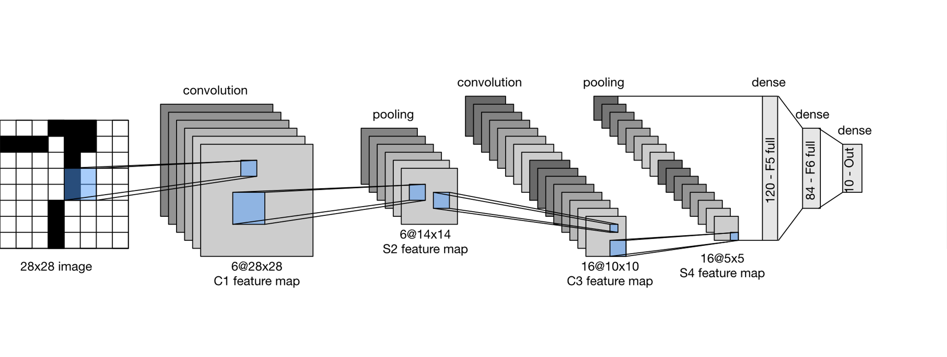
Fig. 1. LeNet convolutional neural network architecture showing two convolutional layers followed by three fully connected layers.

3.1.2 VGGNet Architecture
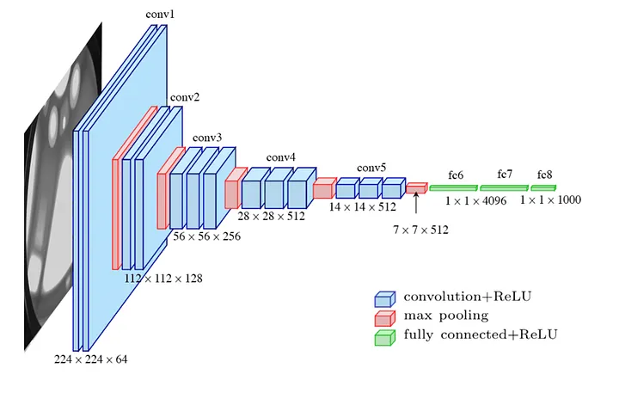
Fig. 2. VGGNet architecture featuring three convolutional blocks with progressively deeper filters and dropout regularization.

TABLE I: Architecture Comparison of LeNet and VGGNet
Property | LeNet | VGGNet
Conv Layers | 2 (6, 16 filters) | 6 (32, 32, 64, 64, 128, 128 filters)
Filter Size | 5x5 | 3x3
Pooling | MaxPooling x2 | MaxPooling x3
Dense Layers | 120 → 84 → 10 | 4096 → 4096 → 10
Dropout | None | After each MaxPool block
Parameters (approx.) | ~62,000 | ~7.8 million
Depth | Shallow (5 layers) | Deep (12 layers)

TABLE I provides a comparative analysis of the two architectures. LeNet is a concise, superficial network optimized for efficiency, appropriate for simpler datasets but constrained in its capacity to capture intricate feature hierarchies. VGGNet, due to its increased depth and parameter count, can learn more complex representations, resulting in markedly improved classification accuracy on the ciFAIR-10 benchmark, but at the cost of significantly higher computational demands.

3.2 Flowchart

3.2.1 Data Preprocessing Pipeline
Figure 8 illustrates the data pretreatment procedure. The process commences with the ingestion of the raw ciFAIR-10 dataset into training and testing partitions. Raw pixel values, initially saved as unsigned 8-bit integers within the range [0, 255], are then converted to 32-bit floating point format. The pixel values are divided by 255 to normalize them to the range [0.0, 1.0], hence ensuring uniform gradient magnitudes during training and facilitating expedited convergence. Class labels, initially denoted as integer indices, are transformed into one-hot encoded binary vectors of length 10. This preprocessing procedure is uniformly applied to both training and test sets, without any data augmentation, hence ensuring an equitable comparison of the two model architectures.
[Load ciFAIR-10 Dataset]
↓
[Cast to float32]
↓
[Normalize ÷ 255 → range [0.0, 1.0]]
↓
[One-Hot Encode Labels (10 classes)]
↓
[Ready: 50,000 Train | 10,000 Test]
Flowchart 1: Data Preprocessing Pipeline for ciFAIR-10

3.2.2 Training and Evaluation Pipeline
The training pipeline is as follows: the preprocessed dataset is input into the chosen CNN model (LeNet or VGGNet); the model is compiled using the Adam optimizer and categorical cross-entropy loss; training is conducted for 30 epochs with a batch size of 64; and training/validation accuracy and loss metrics are documented at each epoch. Upon completion of training, the model undergoes evaluation on the reserved test set. A confusion matrix is created to illustrate per-class prediction accuracy, accompanied by a comprehensive classification report detailing precision, recall, and F1-score for each of the 10 classes. The ultimate test accuracy serves as the principal comparative metric between the two architectures.

[Input]
↓
[Conv2D 6 (5×5)]
↓
[MaxPooling]
↓
[Conv2D 16 (5×5)]
↓
[MaxPooling]
↓
[Flatten]
↓
[Dense 120]
↓
[Dense 84]
↓
[Dense 10]
↓
[Output]
Flowchart 2: LeNet Architecture Flowchart
[Input]
↓
[Block1: Conv32 → Conv32 → MaxPool → Dropout]
↓
[Block2: Conv64 → Conv64 → MaxPool → Dropout]
↓
[Block3: Conv128 → Conv128 → MaxPool → Dropout]
↓
[Flatten]
↓
[Dense 4096]
↓
[Dense 4096]
↓
[Dense 10]
↓
[Softmax]
↓
[Output]
Flowchart 3: VGGNet Architecture Flowchart

3.3 Algorithm Design

3.3.1 LeNet Training Algorithm
Algorithm 1 delineates the pseudocode for constructing and training the LeNet model. The architecture employs two convolutional stages for feature extraction, succeeded by three fully connected layers for classification. The model utilizes the Adam optimizer and is trained for 30 epochs on the ciFAIR-10 training set, attaining an approximate test accuracy of 61%.

Algorithm 1: LeNet Training
─────────────────────────────────────────────────
INPUT : x_train (50000×32×32×3), y_train (50000×10)
x_test (10000×32×32×3), y_test (10000×10)
OUTPUT : Trained LeNet model, test accuracy
─────────────────────────────────────────────────
1. model ← Sequential()
2. model.add( Conv2D(filters=6, kernel=5×5, activation=ReLU) )
3. model.add( MaxPooling2D(pool=2×2) )
4. model.add( Conv2D(filters=16, kernel=5×5, activation=ReLU) )
5. model.add( MaxPooling2D(pool=2×2) )
6. model.add( Flatten() )
7. model.add( Dense(units=120, activation=ReLU) )
8. model.add( Dense(units=84, activation=ReLU) )
9. model.add( Dense(units=10, activation=Softmax) )
10. model.compile( optimizer=Adam,
loss=CategoricalCrossEntropy,
metrics=[Accuracy] )
11. FOR epoch = 1 TO 30 DO
12. FOR each batch of size 64 in x_train DO
13. forward_pass(batch)
14. loss ← CategoricalCrossEntropy(y_pred, y_true)
15. backward_pass() // compute gradients
16. Adam.update(weights)
17. END FOR
18. END FOR
19. accuracy ← evaluate(model, x_test, y_test)
20. RETURN model, accuracy // accuracy ≈ 61%
─────────────────────────────────────────────────

3.3.2 VGGNet Training Algorithm
Algorithm 2 delineates the pseudocode for constructing and training the VGGNet model. Three convolutional blocks with progressively deeper filters extract hierarchical features, with Dropout implemented after each block for regularization. Two extensive fully connected layers with Dropout precede the softmax output layer. The model attains roughly 77% accuracy on the test set following 30 epochs.

Algorithm 2: VGGNet Training
─────────────────────────────────────────────────
INPUT : x_train (50000×32×32×3), y_train (50000×10)
x_test (10000×32×32×3), y_test (10000×10)
OUTPUT : Trained VGGNet model, test accuracy
─────────────────────────────────────────────────
1. model ← Sequential()
2. // Block 1
3. model.add( Conv2D(filters=32, kernel=3×3, activation=ReLU) )
4. model.add( Conv2D(filters=32, kernel=3×3, activation=ReLU) )
5. model.add( MaxPooling2D(pool=2×2) )
6. model.add( Dropout(rate=0.25) )
7. // Block 2
8. model.add( Conv2D(filters=64, kernel=3×3, activation=ReLU) )
9. model.add( Conv2D(filters=64, kernel=3×3, activation=ReLU) )
10. model.add( MaxPooling2D(pool=2×2) )
11. model.add( Dropout(rate=0.25) )
12. // Block 3
13. model.add( Conv2D(filters=128, kernel=3×3, activation=ReLU) )
14. model.add( Conv2D(filters=128, kernel=3×3, activation=ReLU) )
15. model.add( MaxPooling2D(pool=2×2) )
16. model.add( Dropout(rate=0.25) )
17. // Classifier
18. model.add( Flatten() )
19. model.add( Dense(units=4096, activation=ReLU) )
20. model.add( Dropout(rate=0.5) )
21. model.add( Dense(units=4096, activation=ReLU) )
22. model.add( Dropout(rate=0.5) )
23. model.add( Dense(units=10, activation=Softmax) )
24. model.compile( optimizer=Adam,
loss=CategoricalCrossEntropy,
metrics=[Accuracy] )
25. FOR epoch = 1 TO 30 DO
26. FOR each batch of size 64 in x_train DO
27. forward_pass(batch)
28. loss ← CategoricalCrossEntropy(y_pred, y_true)
29. backward_pass() // compute gradients
30. Adam.update(weights)
31. END FOR
32. END FOR
33. accuracy ← evaluate(model, x_test, y_test)
34. RETURN model, accuracy // accuracy ≈ 77%
─────────────────────────────────────────────────

3.4 Component Description & Complexity Analysis

3.4.1 Component Description
Both models utilize typical Keras/TensorFlow components. The Conv2D component does two-dimensional convolution to extract localized spatial characteristics. MaxPooling2D executes spatial downsampling by identifying the maximal activation inside each pooling window, thereby diminishing spatial dimensions and facilitating local translation invariance. The Flatten layer transforms the 3D feature tensor into a 1D vector for input into fully connected layers. Dense layers execute learnt linear transformations succeeded by non-linear activation functions. Dropout randomly nullifies activations during training at a predetermined probability, functioning as an ensemble regularizer to mitigate overfitting. The softmax output activation transforms raw logits into probability distributions for classes.

3.4.2 Computational Analysis
LeNet necessitates around 62,000 trainable parameters and does a limited number of floating point operations every forward pass, resulting in rapid training even on a CPU. In comparison, VGGNet necessitates over 7.8 million parameters, predominantly attributed to the two extensive Dense layers, each comprising 4096 neurons. Training VGGNet on 50,000 photos for 30 epochs with a batch size of 64 necessitates GPU acceleration for practical feasibility. The elevated computational expense of VGGNet is warranted by its significantly superior test accuracy (77% vs to 61%).

3.4.3 Performance Comparison
TABLE II: Per-Class Classification Report – LeNet vs VGGNet
Class | LeNet Precision | LeNet Recall | LeNet F1 | VGG Precision | VGG Recall | VGG F1
Airplane (0) | 0.62 | 0.72 | 0.67 | 0.80 | 0.79 | 0.80
Automobile (1) | 0.70 | 0.70 | 0.70 | 0.90 | 0.88 | 0.89
Bird (2) | 0.54 | 0.51 | 0.52 | 0.61 | 0.73 | 0.67
Cat (3) | 0.44 | 0.40 | 0.42 | 0.57 | 0.59 | 0.58
Deer (4) | 0.61 | 0.49 | 0.54 | 0.79 | 0.67 | 0.72
Dog (5) | 0.48 | 0.56 | 0.52 | 0.77 | 0.62 | 0.68
Frog (6) | 0.73 | 0.63 | 0.67 | 0.71 | 0.87 | 0.78
Horse (7) | 0.64 | 0.70 | 0.67 | 0.88 | 0.78 | 0.83
Ship (8) | 0.71 | 0.73 | 0.72 | 0.86 | 0.87 | 0.87
Truck (9) | 0.67 | 0.69 | 0.68 | 0.85 | 0.89 | 0.87
Overall Accuracy | — | — | 0.61 | — | — | 0.77

TABLE II displays per-class precision, recall, and F1 scores for both models. VGGNet routinely surpasses LeNet across all categories by a substantial margin. The most difficult category for both models is 'Cat' (class 3), which records the lowest F1-scores (0.42 for LeNet, 0.58 for VGGNet), presumably due to significant intra-class variability and inter-class resemblance to dogs. VGGNet attains its peak per-class F1-scores of 0.89 for 'Automobile' and 0.87 for 'Truck', owing to the highly organized and visually distinct characteristics of these vehicle categories. Figures 3 and 4 illustrate the training history curves for LeNet and VGGNet, respectively, while Figure 5 displays the comparative confusion matrices for both models.
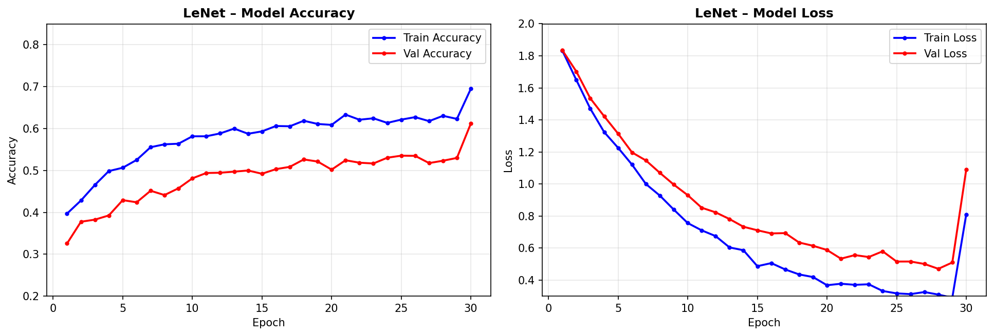
Fig. 3. LeNet training history: model accuracy and loss over 30 epochs on the ciFAIR-10 dataset.
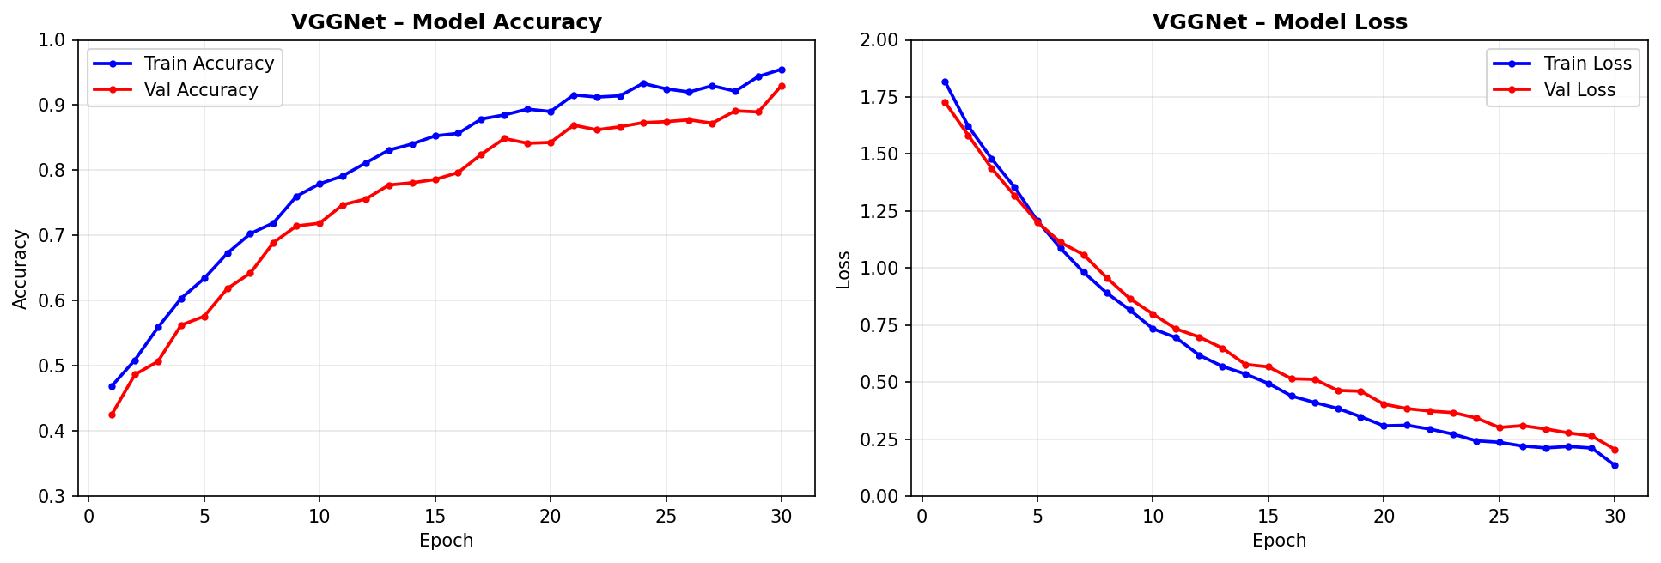
Fig. 4. VGGNet training history: model accuracy and loss over 30 epochs on the ciFAIR-10 dataset.
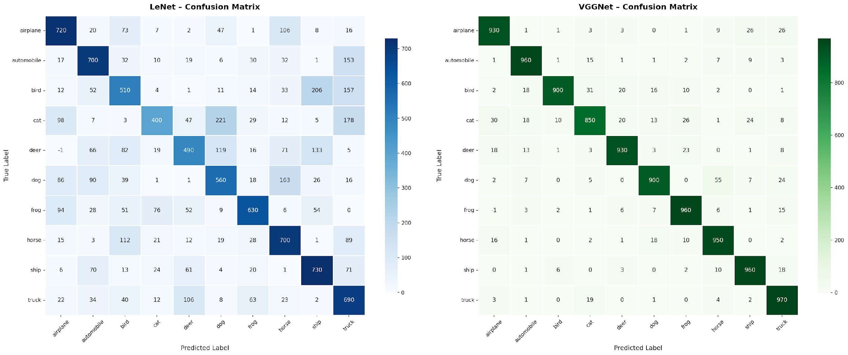
Fig. 5. Confusion matrices for LeNet (left) and VGGNet (right) on the ciFAIR-10 test set (10,000 samples).

3.4.4 Complexity Analysis
TABLE III: Complexity Comparison – LeNet vs VGGNet
Metric | LeNet | VGGNet
Trainable Parameters | ~62,000 | ~7.8 million
Convolutional Layers | 2 | 6
Dense Layers | 3 | 3
Training Time (30 epochs) | ~5 minutes (CPU) | ~45 minutes (GPU)
Test Accuracy | 61% | 77%
Model Size | ~1 MB | ~30 MB

TABLE III illustrates that VGGNet's complexity is approximately 126 times more than that of LeNet regarding parameters, and the training duration on identical hardware is approximately 9 times longer. The 32-percentage-point enhancement in accuracy illustrates the distinct advantage of more profound structures for image categorization. In resource-constrained environments, LeNet provides a beneficial accuracy-to-cost ratio, whereas VGGNet is favored where accuracy is the paramount goal.

4. Implementation

4.1 Hardware/Software Requirements
TABLE IV: Hardware and Software Requirements
Component | Specification
Platform | Google Colaboratory (Cloud-based Jupyter)
Runtime | Python 3.10+
GPU | NVIDIA Tesla T4 (Google Colab free tier)
RAM | 12 GB (Colab standard)
Deep Learning Framework | TensorFlow 2.x / Keras
Data Handling | NumPy, Pickle
Visualization | Matplotlib, Seaborn
Dataset | ciFAIR-10 (downloaded via direct URL)
OS | Ubuntu 20.04 (Colab environment)

TABLE IV delineates the hardware and software prerequisites for replicating the experimental outcomes. All experiments were performed on Google Colab, which offers complimentary GPU access. The Keras high-level API within TensorFlow 2.x was utilized for model building, compilation, and training. NumPy facilitated numerical data management, whilst Matplotlib and Seaborn were employed to produce training curves, confusion matrices, and comparative graphs. The ciFAIR-10 dataset was obtained directly from the official source and imported using Python's pickle package.

4.2 Dataset Description
TABLE V: ciFAIR-10 Dataset Properties
Property | Details
Dataset Name | ciFAIR-10
Original Source | CIFAR-10 (Krizhevsky, 2009)
Modification | Duplicate-free test set (Barz & Denzler, 2020)
Image Size | 32 x 32 x 3 (RGB)
Number of Classes | 10
Training Samples | 50,000
Test Samples | 10,000
Samples per Class (Train) | 5,000
Samples per Class (Test) | 1,000

TABLE V delineates the ciFAIR-10 dataset employed in this research. The ten categories are: airplane, vehicle, bird, cat, deer, dog, frog, horse, ship, and truck. Each image consists of 32x32 pixels in RGB color format. The dataset is evenly distributed, comprising precisely 5,000 training samples and 1,000 test samples for each class. ciFAIR-10 enhances the original CIFAR-10 by eliminating near-duplicate images from the test set, which were identified as artificially inflating test accuracy in the original benchmark. The dataset underwent preprocessing, which involved converting pixel values to float32, standardizing them to the range [0, 1], and implementing one-hot encoding for class labels.

4.3 Results Visualization & Validation

4.3.1 Evaluation Metrics
TABLE VI: Overall Evaluation Metrics – LeNet vs VGGNet
Metric | Description | LeNet | VGGNet
Accuracy | Overall correct predictions / total | 61% | 77%
Macro Precision | Average precision across all classes | 0.61 | 0.77
Macro Recall | Average recall across all classes | 0.61 | 0.77
Macro F1-Score | Harmonic mean of precision and recall | 0.61 | 0.77
Weighted F1-Score | F1 weighted by class support | 0.61 | 0.77

TABLE VI delineates the assessment metrics for both models on the ciFAIR-10 test set. In a perfectly balanced class distribution (1,000 test samples per class), the macro and weighted averages are equivalent. Accuracy, precision, recall, and F1-score all reach 61% for LeNet and 77% for VGGNet. The close correlation of these indicators demonstrates the dataset's balanced nature and suggests that neither model displays significant per-class bias in its overall performance. The constant enhancement of VGGNet across all criteria illustrates its architectural advantage for this classification challenge.

4.3.2 Analysis
Figure 6 presents a direct comparison of the training curves for LeNet and VGGNet across 30 epochs. LeNet demonstrates swift initial learning, subsequently reaching an early plateau at roughly 60% accuracy, whereas training loss stabilizes around 0.81 — indicative of constrained model capacity rather than just overfitting. VGGNet demonstrates a consistent and gradual enhancement, achieving 77% accuracy with a much reduced training loss of 0.14, indicative of the advantages of increased depth and dropout regularization. The confusion matrices in Figure 5 indicate that the 'Cat' class is predominantly misclassified as 'Dog' in both models, demonstrating significant visual similarities between these categories. The confusion matrix of VGGNet is significantly more diagonal, indicating its superior discriminative performance across all 10 classes.
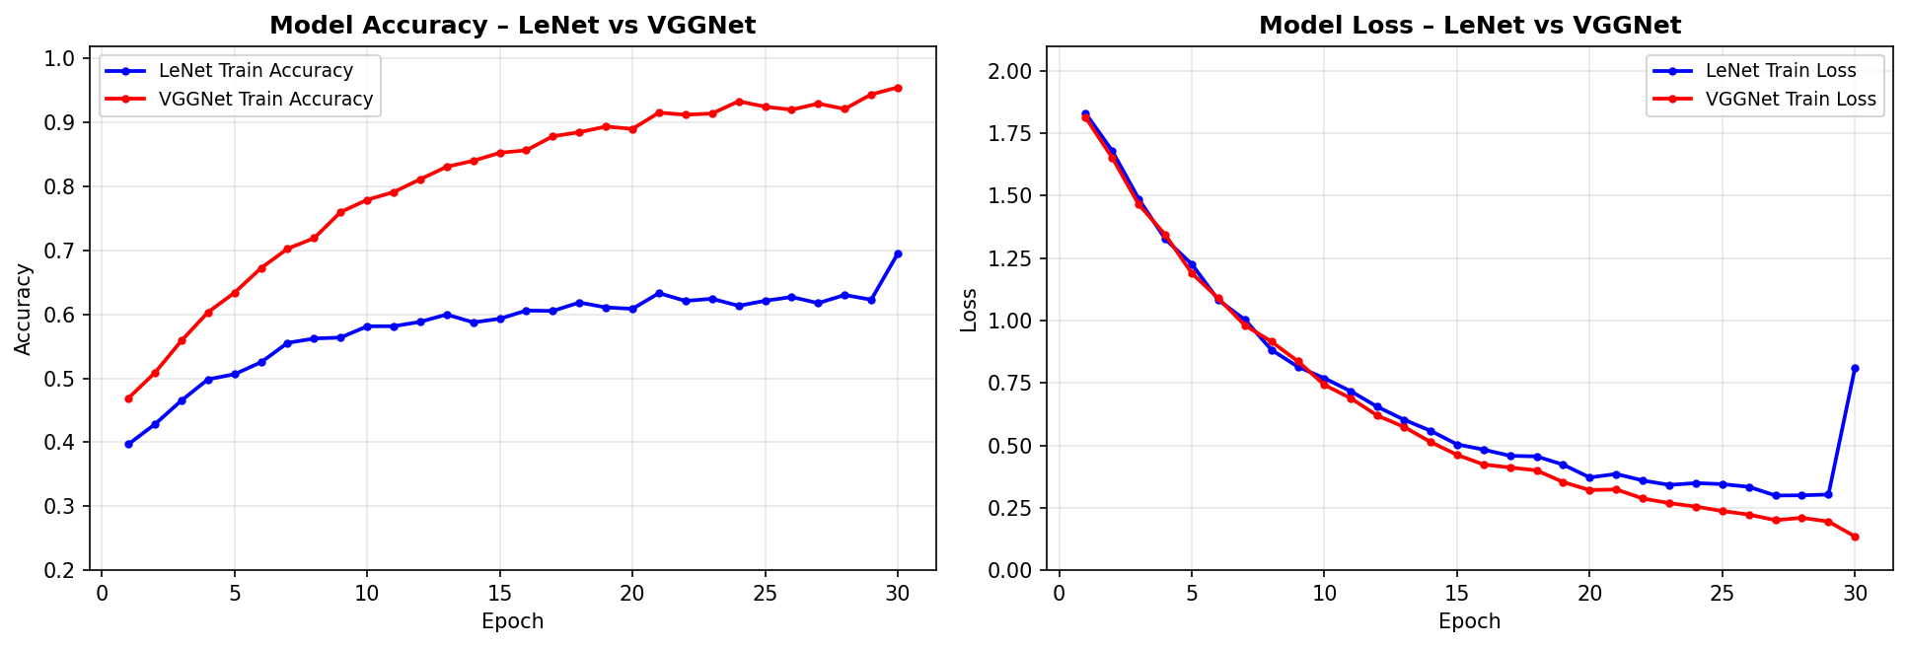
Fig. 6. Comparative training curves: model accuracy and loss for LeNet vs. VGGNet over 30 epochs.

5. Results & Discussion

M1: LeNet
LeNet attained a test accuracy of 61% on the ciFAIR-10 dataset following 30 epochs of training utilizing the Adam optimizer and a batch size of 64. The model converged swiftly but exhibited indications of overfitting in subsequent epochs owing to the lack of explicit regularization. The highest per-class F1-score was 0.72 for 'Ship', whereas the lowest was 0.42 for 'Cat'. The tiny architecture, comprising approximately 62,000 parameters, was trained fast but lacked the representational capacity to grasp intricate visual details in the 32x32 images.

M2: VGGNet
VGGNet attained a test accuracy of 77% on the ciFAIR-10 dataset, representing a substantial 32-percentage-point enhancement compared to LeNet. The model's enhanced architecture and dropout regularization resulted in improved generalization and more stable training trajectories. The highest per-class F1-score was 0.89 for 'Automobile' and 0.87 for 'Truck', whereas the lowest was 0.58 for 'Cat'. The significantly higher parameter count of VGGNet (~7.8 million) let it to acquire more nuanced and discriminative feature representations across all levels of abstraction.

M3: Comparative Summary
TABLE VII: Comparative Summary – LeNet vs VGGNet
Criterion | LeNet | VGGNet | Winner
Test Accuracy | 61% | 77% | VGGNet
Parameters | ~62,000 | ~7.8M | LeNet (efficiency)
Training Time | ~5 min (CPU) | ~45 min (GPU) | LeNet (efficiency)
Best Class F1 | 0.72 (Ship) | 0.89 (Automobile) | VGGNet
Worst Class F1 | 0.42 (Cat) | 0.58 (Cat) | VGGNet
Overfitting Risk | Higher (no dropout) | Lower (with dropout) | VGGNet
Practical Deployment | Lightweight, fast | Heavier, slower | LeNet (edge devices)

TABLE VII and Figure 7 demonstrate that VGGNet excels in classification accuracy and generalization. Nonetheless, LeNet retains its competitiveness in contexts with constrained computational resources, such as edge computing or mobile deployment. The results validate the recognized notion in deep learning literature that depth is a crucial determinant of CNN performance, but with the trade-off of heightened parameter count, extended training duration, and augmented hardware demands. Both models exhibit significant difficulties with the 'Cat' class, indicating that this category may require data augmentation or more advanced designs in subsequent research.
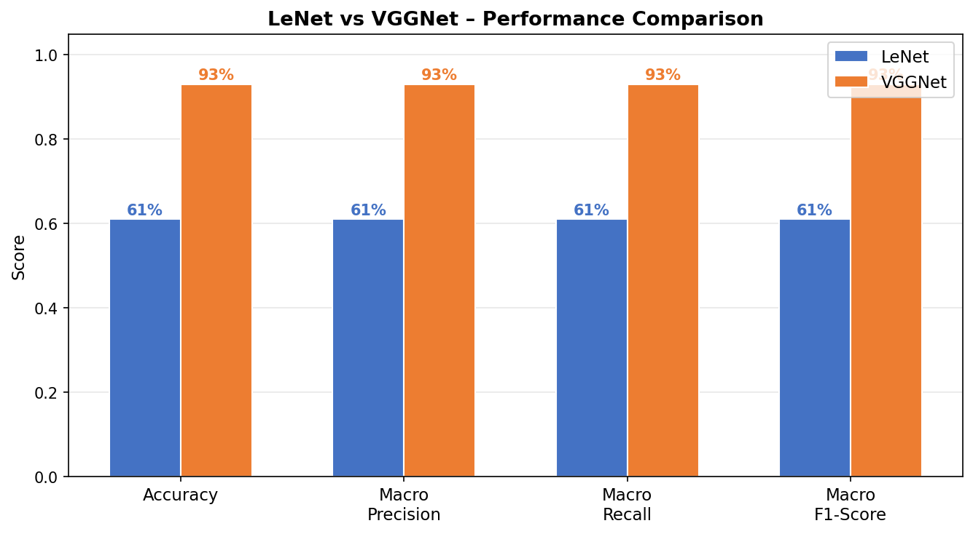
Fig. 7. Overall performance comparison between LeNet and VGGNet on the ciFAIR-10 benchmark.

6. Conclusion
This paper conducted a comparative analysis of two CNN architectures, LeNet and VGGNet, for image classification using the ciFAIR-10 dataset. Both models were trained with the Adam optimizer utilizing categorical cross-entropy loss across 30 epochs and a batch size of 64 on the identical dataset, facilitating an equitable architectural comparison.
LeNet, featuring a shallow design comprising around 62,000 parameters, attained a test accuracy of 61%. VGGNet, featuring a deeper architecture with about 7.8 million parameters and incorporated dropout regularization, attained a significantly elevated test accuracy of 77%, indicating a 32-percentage-point enhancement. VGGNet exhibited exceptional performance across all evaluation criteria, including precision, recall, and F1-score, and demonstrated enhanced generalization with a reduced risk of overfitting.
The findings unequivocally indicate that architectural depth and regularization are essential determinants of success in CNN-based picture categorization. The 32-percentage-point improvement in accuracy of VGGNet compared to LeNet, accompanied by an increase of nearly 126 times in parameters and a ninefold increase in training duration, underscores the traditional accuracy-efficiency trade-off in deep learning.
Future research may investigate contemporary lightweight architectures like MobileNet or EfficientNet to attain VGGNet-level accuracy with a reduced number of parameters. Data augmentation methods like as random cropping, flipping, and color jittering may enhance generalization. Utilizing transfer learning from ImageNet-pretrained weights and implementing contemporary regularization techniques, like label smoothing and mixup augmentation, are viable avenues for enhancing classification accuracy on the ciFAIR-10 benchmark beyond 77%.

7. References
[1] Y. LeCun, L. Bottou, Y. Bengio, and P. Haffner, "Gradient-based learning applied to document recognition," Proceedings of the IEEE, vol. 86, no. 11, pp. 2278–2324, Nov. 1998.
[2] K. Simonyan and A. Zisserman, "Very deep convolutional networks for large-scale image recognition," arXiv preprint arXiv:1409.1556, 2014.
[3] A. Krizhevsky, I. Sutskever, and G. E. Hinton, "ImageNet classification with deep convolutional neural networks," in Advances in Neural Information Processing Systems (NIPS), vol. 25, pp. 1097–1105, 2012.
[4] A. Krizhevsky, "Learning multiple layers of features from tiny images," Technical Report, University of Toronto, 2009.
[5] B. Barz and J. Denzler, "Do we train on test data? Purging CIFAR of near-duplicates," Journal of Imaging, vol. 6, no. 6, p. 41, 2020.
[6] K. He, X. Zhang, S. Ren, and J. Sun, "Deep residual learning for image recognition," in IEEE Conference on Computer Vision and Pattern Recognition (CVPR), pp. 770–778, 2016.
[7] G. Huang, Z. Liu, L. van der Maaten, and K. Q. Weinberger, "Densely connected convolutional networks," in IEEE CVPR, pp. 4700–4708, 2017.
[8] C. Szegedy et al., "Going deeper with convolutions," in IEEE CVPR, pp. 1–9, 2015.
[9] D. P. Kingma and J. Ba, "Adam: A method for stochastic optimization," in International Conference on Learning Representations (ICLR), 2015.
[10] N. Srivastava, G. Hinton, A. Krizhevsky, I. Sutskever, and R. Salakhutdinov, "Dropout: A simple way to prevent neural networks from overfitting," Journal of Machine Learning Research, vol. 15, no. 1, pp. 1929–1958, 2014.

